
California Tickets  Updated: 3/20/2026 | ELIGIBILITY: All Active Duty, Retired, Reservists, National Guard, DoD, Alumni Association, NAAA, and full-time USNA Contractors and Eligible Veterans.
***************ALL SALES ARE FINAL******************NO REFUNDS******************NO EXCHANGES******************
Closed Holidays. Prices Subject to Change Without Notice
Disneyland Military Salute 2026
Sale Dates 1/1/2026 – 12/31/2026
Disneyland 3-Day Park Hopper Military Salute: $314.00
Disneyland 3-Day Park Hopper with Lightning Lane Military Salute: $416.00
Disneyland 4-Day Park Hopper Military Salute: $369.00
Disneyland 4-Day Park Hopper with Lightning Lane Military Salute: $505.00
A valid and active U.S. Military (or spouse) ID is required for admission.



Ages 3+ Gate MWR Price
1-Day (non/mid)Peak $159.00 $99-$122.50
Please see calendar with dates and pricing
MIL Pass $189.00



Gate MWR Price
Ages 3+ $110.00


Carlsbad, CA

Gate MWR Price

Legoland 1-Day (3+) $102.90 $69.25
Legoland/Sea $120.00 $72.00
Buy 1 Day Get the 2nd day (within 9 days)
2day -
Legoland/Sea/Waterpark $127.90 $89.50


https://aquatica.com/sandiego/tickets/reservations/
https://seaworld.com/sandiego/tickets/reservations-members/

Gate MWR Price
SWSD Single Day
All ages 3+ $99.99 $50.50
With All Day Dine $169.00 $88.00
SWSD MIL PASS $191.99 $111.75
SWSD Buy Adult Get Kid Free $106.25
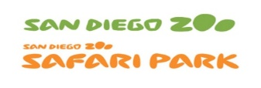

San Diego Zoo OR San Diego Safari Park
Gate MWR Price
Adult $78.00 $ 64.50
Child (3-11 yrs) $68.00 $ 56.25

San Diego Zoo AND Safari Park – 2 visits Gate MWR Price
Adult $128.00 $ 126.75
Child (3-11 yrs) $118.00 $ 117.00

**U.S. Active Duty Free admission with ID card



Schedule your visit for all members of your party at https://www.knotts.com/reservations
Gate MWR Price
Knott’s Single Day $110.00 $
Knott’s Soak City $70.00 $



Gate MWR Price
Adult $44.95 $
Child (3-11) $34.95 $


Gate MWR Price
Adult $73.00 $76.75
Child (3-11) $63.00 $66.00

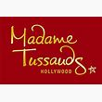

Gate MWR Price
MDM + Marvel 4D $34.99 $

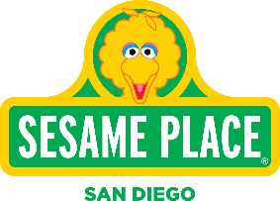 Gate MWR Price
Sesame Place 2 park $154.98 $



www.trolleytours.com.
(Other ticket options available upon request)
Gate MWR Price
1-Day Pass
Adult $54.00 $46.50
Child $35.00 $29.50

2-Day Pass
Adult $93.00 $79.25
Child $89.99 $56.50

San Diego City Lights
Adult/Child $42.00 $39.50
Infant $10.00 $8.75

San Diego Ghost
Adult/Child $42.00 $41.25

San Diego SEAL tour
Adult $53.41 $45.00
Child $35.97 $33.25
Infant $10.90 $9.25



SAVE UP TO 55% ON TOP CITY ATRACTIONS
1, 2, 3, 4 or 5 Day Passes and/or Pick 2, 3, 4 or 5 attractions.

San Diego $111.50– $173.00
San Francisco $93.75– $177.50
Los Angeles $115.75 – $208.25

